SPRINT 4

|  |  |
| --- | --- |
| Date | 17-11-2022 |
| Team ID | PNT2022TMID12349 |
| Project Name | Personal Assistance for Seniors Who Are Self-  Reliant. |

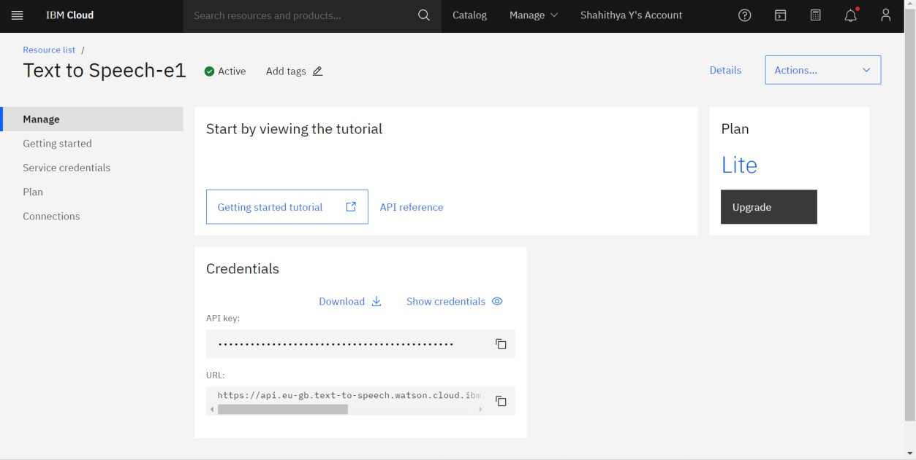Text-To-Speech Service:

Python code to send the reminder to take the medicine : from ibm_watson import TextToSpeechV1

from ibm_cloud_sdk_core.authenticators import vIAMAuthenticator from playsound import playsound

authenticator=IAMAuthenticator('2dXKbVbjkbyNGPnN2V5F_1D0kxB FLSFBc-6M2vVKgVHK')

text_to_speech=TextToSpeechV1(authenticator=authenticator)

text_to_speech.set_service_url('https://api.eu-gb.text-to- speech.watson.cloud.ibm.com/instances/547e2c7b-deac-45bd-970d- a37fdf62f98d')

with open('med.mp3','wb')as audio_file: audio_file.write(

text_to_speech.synthesize) 'Take Crocin Now',

voice='en-US_AllisonV3Voice', accept='audio/wav'

).get_result().content) print("Playing") playsound('med.mp3')

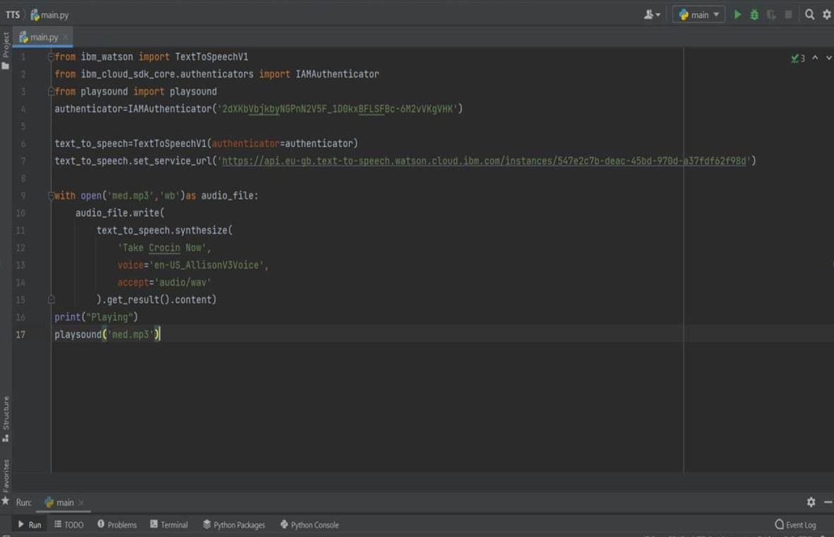

Reminder Message:

